1)

b)

Input voltage Vin = 48V

Output (full load) 24 V at 4.16 A

We chose:

Switching frequency 250 kHz

Assuming Magnetizing current ripple 4% of dc magnetizing current

Duty cycle D = 0.4

Turns ratio n1/ n2 = 1.33

Fill factor Ku = 0.3 is assumed.

Pcu=5W

Maximum flux density Bmax = 0.25 T is used. This value is less than the worst-case saturation flux density of the ferrite core material.

Components of magnetizing current, referred to primary:

$$I_{m}=\frac{n_{1}}{n_{2}}\frac{1}{1-D}\frac{V_{0}}{R_{L}}$$

$$I_{m}=5.22 A$$

∆IM=0.1044A

$$L_{m}=\frac{V_{in}DT_{s}}{2∆I_{M}}$$

=0.072mH

The rms value of the primary winding current is found as follows (this equation taken from Fundamentals of Power Electronics 2nd edition Erickson appendix A eq. (A.6));

$$I_{1rms}=I_{M}\sqrt{D}\sqrt{1+\frac{1}{3}{(\frac{{∆I}_{M}}{I_{M}})}^{2}}$$

=3.3 A

The rms value of the secondary winding current is found as follows;

$$I_{2rms}=\frac{n_{1}}{n_{2}}I_{M}\sqrt{1-D}\sqrt{1+\frac{1}{3}{(\frac{{∆I}_{M}}{I_{M}})}^{2}}$$

=5.37 A

The total rms winding current is equal to:

$$I_{total}=I_{1}+\frac{n_{2}}{n_{1}}I_{2}$$

=7.33 A

We can now determine the necessary core size.

$$K_{g}≥\frac{p{{(L}_{M}*I_{total}*I_{M,max})}^{2}}{{B_{Max}}^{2}*P_{cu}*K_{u}}*{10}^{8}$$

$$=\frac{1.724*{10}^{-6}{(0.18*{10}^{-3}*7.33*5.3)}^{2}}{{0.25}^{2}*5*0.3}$$

$$=0.0875{ cm}^{5}$$

The smallest EE core listed in figure 3 that satisfies this inequality is the ETD29, which has kg= The dimensions of this core is as follows;

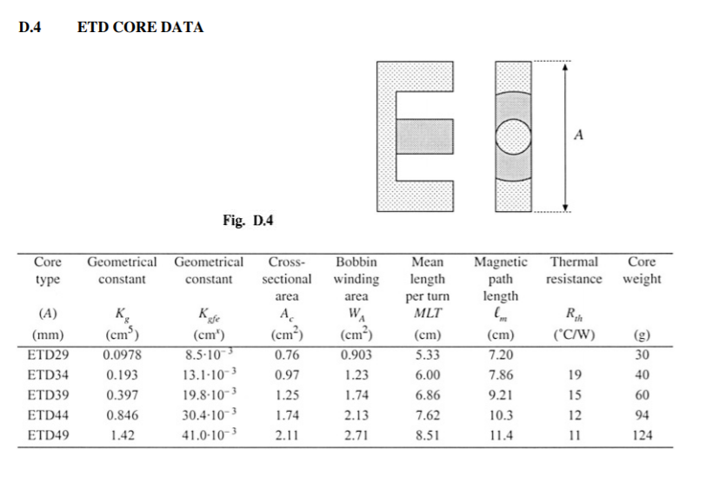

Figure 1.ETD Core Data( taken from taken from Fundamentals of Power Electronics 2nd edition Erickson appendix D)

The air gap length is chosen as follows;

$$l_{g}=\frac{µ_{0}*{L_{M}*I_{M,max}}^{2}}{{B_{Max}}^{2}*A_{c}}*{10}^{4}=1.34 mm$$

The number of winding 1 turns is chosen as follows;

$$n_{1}=\frac{L_{M}*I_{M,max}}{B_{Max}*A_{c}}*{10}^{4}=50.21 turns$$

Since an integral number of turns is required, we round off this value to

$$n_{1}=51$$

To obtain the desired turns ratio, n2 should be chosen as follows:

$$n_{2}=\left(\frac{n_{2}}{n_{1}}\right)*n_{1}$$

$$n_{2}=38.34$$

We again round this value off, to

$$n_{2}=39 turns$$

For the flyback transformer example, the peak ac flux density is found to be as follows;

$$ΔB=\frac{V_{in}*T_{s}*D}{{2*n}_{1}*A_{c}}=0.01 T$$

c)

When average magnetization current equal to half of the ripple on magnetization current system goes DCM mode.

$$I_{M,avg}=\frac{ΔI_{M}}{2}=\frac{V_{in}DT_{s}}{2L_{m}}=0.533 A$$

$$I_{L}=\left(1-D\right)I_{M,avg}*\frac{n_{1}}{n_{2}}=0.425 A$$

0.425 A is minimum current of load for working with without getting into the DCM.